EDMONTON MASTERS CYCLING CLUB

EDMONTON RESEARCH PARK – Criterium course, ± 1.35 km laps

MAY 9th 2018 7:00 pm Sign-on 6:00 pm Omnium: TT, Scratch, Win & Out, H/cap
JUNE 06th 2018 7:30 pm Sign-on 6:30 pm Omnium: TT, Scratch, Win & Out, H/cap
JULY 04th 2018 7:30 pm Sign-on 6:30 pm Omnium: TT, Scratch, Win & Out, H/cap
AUGUST 08th 2018 7:30 pm Sign-on 6:30 pm Omnium: TT, Scratch, Win & Out, H/cap
SEPT 12th 2018 6:30 pm Sign-on 5:30 pm Ability Group Handicap, 25 mins + 3 laps

ALL RIDERS AND HELPERS MUST BE PAID-UP MEMBERS OF EMCC.

COURSE DESCRIPTION

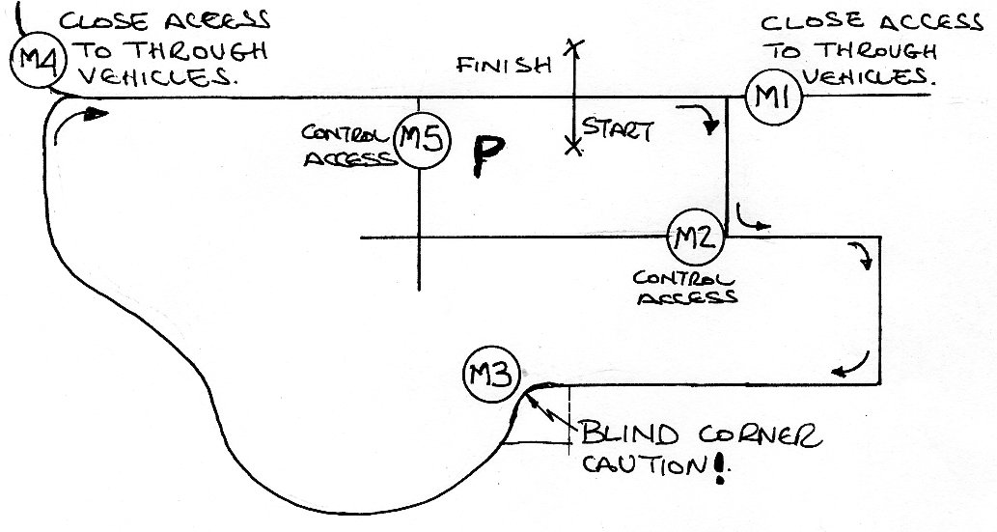

PARKING

Park in the ERC parking lot, inside the circuit, behind the Start/Finish line.

OFFICIALS/MARSHALS

JUDGES (2) START/FINISH (at bus shelter).

MARSHAL #1 At end of start/finish straight – CLOSE ACCESS TO THROUGH VEHICLES.

MARSHAL #2 At east parking lot access – CONTROL ACCESS.

MARSHAL #3 At Karl Clark Building main entrance – BLIND CORNER.

MARSHAL #4 At start of start/finish straight – CLOSE ACCESS TO THROUGH VEHICLES.

MARSHAL #5 At west parking lot access – CONTROL ACCESS.

